**Writing the body paragraphs NCC Novel Persuasive Research Paper**

You are poised to write your body paragraphs for this research paper. You have all the pieces you need.

1. Thesis statement with a theme and two/three story elements

2. Sentences from the novel to support your story elements

3. Sentences from critics to support your story elements

Before you start writing, here are some reminders:

1. The paper needs to be 5-7 pages in length (To the end of page five, no longer than page seven of writing. Works Cited doesn’t count in the page tally)
2. You need to have 5 sources total
   1. Novel
   2. Author background
   3. Critic article
   4. Critic article
   5. Critic article
3. You can write a four-paragraph essay or a five-paragraph essay.
4. Each paragraph explores a different story element from your thesis. Try to keep each element contained within its own body paragraph.
5. Each paragraph should have a mix of novel quote(s) and critic quote(s).
6. This is a FORMAL paper. No “you”, “I”, “we” or other personal pronouns in your paper. You can use the words readers, people, society…instead. It’s okay to use ‘you’ in the grabber in the introductory paragraph or the lasting impression in the conclusion – but these with ‘you’ first.

Body Paragraph Structure:

You already completed a preliminary outline where you selected evidence.

You will need to **deliver** and **analyze** that evidence in your body paragraphs.

**Here is the typical body paragraph structure:**

* Transition word with topic sentence
* Build up to a piece of evidence (provide context for your evidence-where did it come from?)
* Your evidence (sentences from the novel or critic) with an internal citation (matches your source citation)
* Explanation/analysis in your own words (you being the expert that is supporting your thesis)
* Transition to next piece of evidence build up (provide context for your evidence-where did it come from?)
* Your evidence (sentences from the novel or critic) with an internal citation (matches your source citation)
* Explanation/analysis in your own words (you being the expert that supporting your thesis)
* Transition to next piece of evidence build up (provide context for your evidence-where did it come from?)
* Your evidence (sentences from the novel or critic) with an internal citation (matches your source citation)
* Explanation/analysis in your own words (you being the expert that supporting your thesis)
* Clinching sentence

**What’s Next?**

* Some writers like to outline their plans for how to lead into the evidence and what they want to say to analyze it.
* Some writers are satisfied with the preliminary outline and the body paragraph structure reminders above and are ready to start writing.

**Support**

If you would like to outline further, you can create your own outline structure or use the one offered on Canvas. Keep in mind, though, that you may choose different amounts of novel evidence and critic evidence in your body paragraphs. This means that the outline might not be a perfect fit.

Graphic Organizer Outline Style

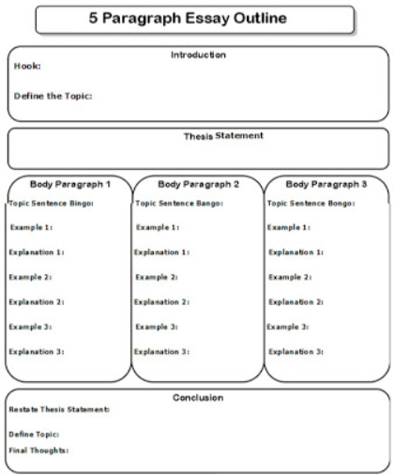

Alphanumeric Outline Style

I. Body Paragraph #1

A. Topic sentence

i. First, Orwell expresses the dangers of a powerful government through the use of characterization.

B. Evidence #1

i. evidence lead in

a. In the first part of the novel readers meet Winston Smith, and he when reading the date he is described as experiencing

ii. novel evidence

1. “A sense of complete helplessness…” (Orwell 4)

iii. analysis